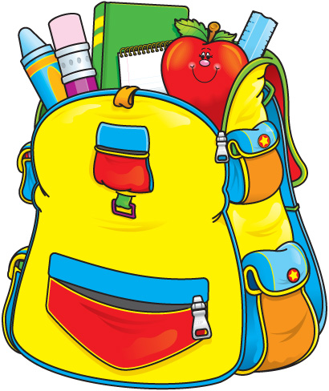

Greenock Elementary School
Second Grade Supply List
2018-2019

Many parents have asked what are appropriate materials to send with your child to second grade. Here is a list of items your child will need:

1 full sized backpack
1 large box of Kleenex
1 plastic pencil box (8” x 5” only)
2 box of crayons
4 large glue sticks (1 per 9 weeks)
1 pair of round tipped scissors
1 pack of markers
5 dozen Pencils – pre- sharpened if you can find them.
1 set headphones or earbuds -In a Ziploc bag, please label with a sharpie

Please pack the box of crayons, a glue stick, scissors, and 3 pencils in the plastic pencil box for the first day. All extra supplies can be sent in a large Ziplock bag with your child’s name on in. This will help us have a smooth first day of school.

All items will be on sale after July 4th at stores like Target and
Wal-Mart.

If you need assistance, please contact Mrs. Meliton at jmeliton@efsd.net

